**Movie Store database program**

**Yara Al-Dummor 202210928**

**Maryam Sherwqi 202210847**

**Movie Store database program python project:**

A program which stores user’s Movie store data in a list along with movie name, date released and price.

The program will have:

* Log in to user information
* Menu which you choose to be a worker or a shopper
* Worker menu which includes (add movie, remove a movie and show list for all movies )
* Shopper menu which includes(buy movies ,show list for all movies and add feedback)

The program will use GUI Tkinter, lists, object-oriented programming, and built-in functions.

**Run:**

**Log in menu**

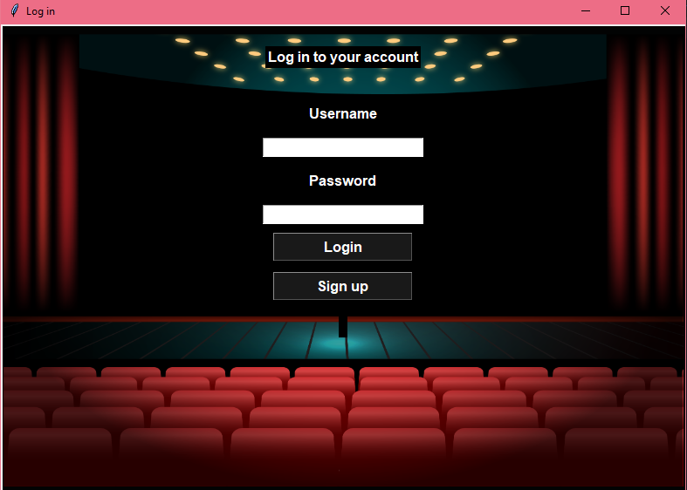

**Worker and shopper menu**

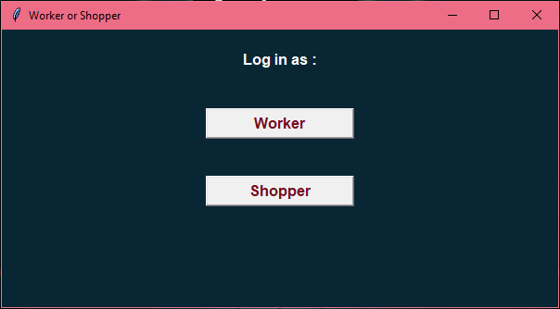

**Worker menu**

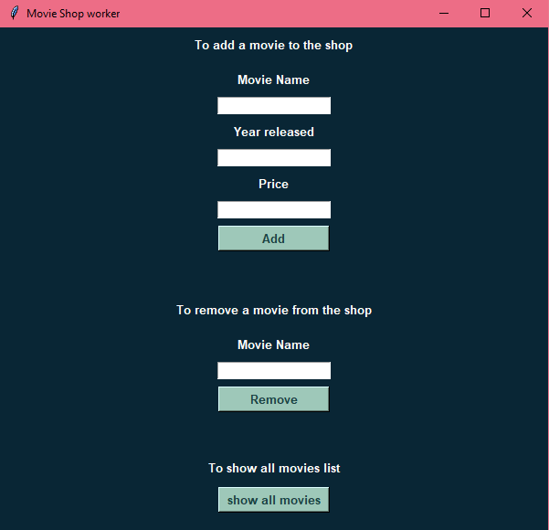

**Shopper menu**

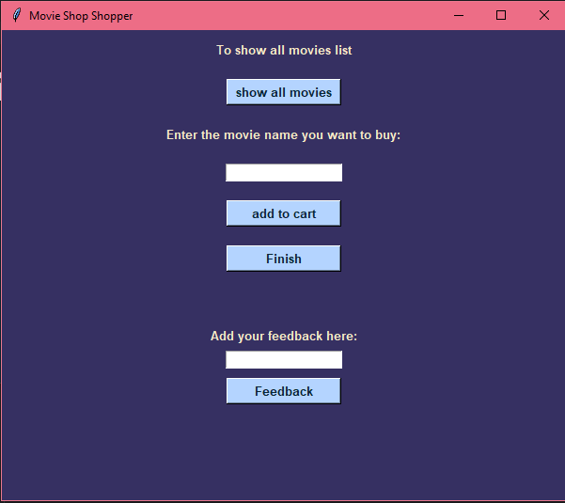

**Show movie list menu**

